Event Venue Booking System – SRS Document

1. Introduction

1.1 Purpose
The purpose of this document is to provide a detailed overview of the VenueSync Event Venue Booking System. It outlines the functional and non-functional requirements for the platform.

1.2 Project Scope
VenueSync is a web-based platform that allows users to search, view, and book event venues across multiple cities (e.g., Karachi, Lahore, Islamabad). It simplifies the event planning process by providing real-time pricing, guest capacity filters, and location-based searches.

2. System Overview

2.1 User Roles
- Guest/Customer: Can browse venues, search by location/date, and view details.
- Registered User: Can perform all guest actions plus book venues and manage their profile.
- Admin: (Implicit) Manages venue listings, approves bookings, and monitors system activity.
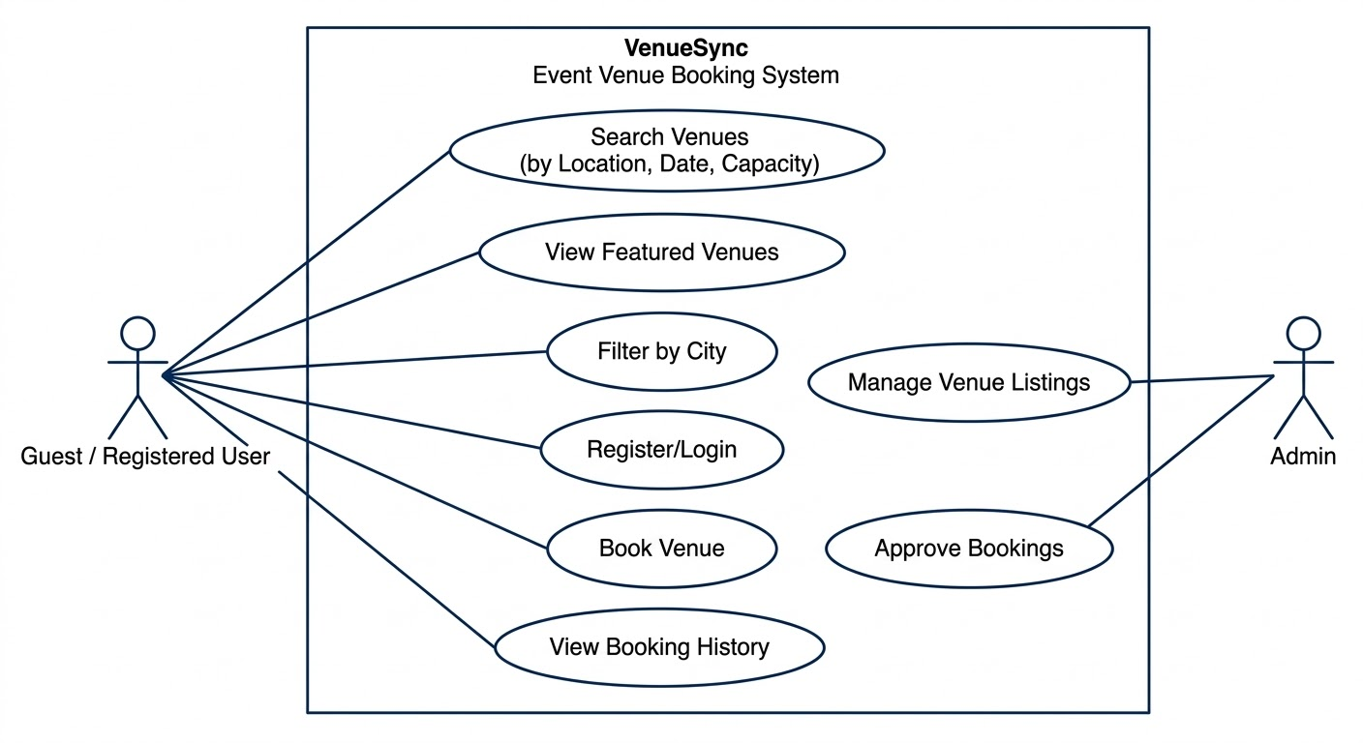

2.2 ER Diagram

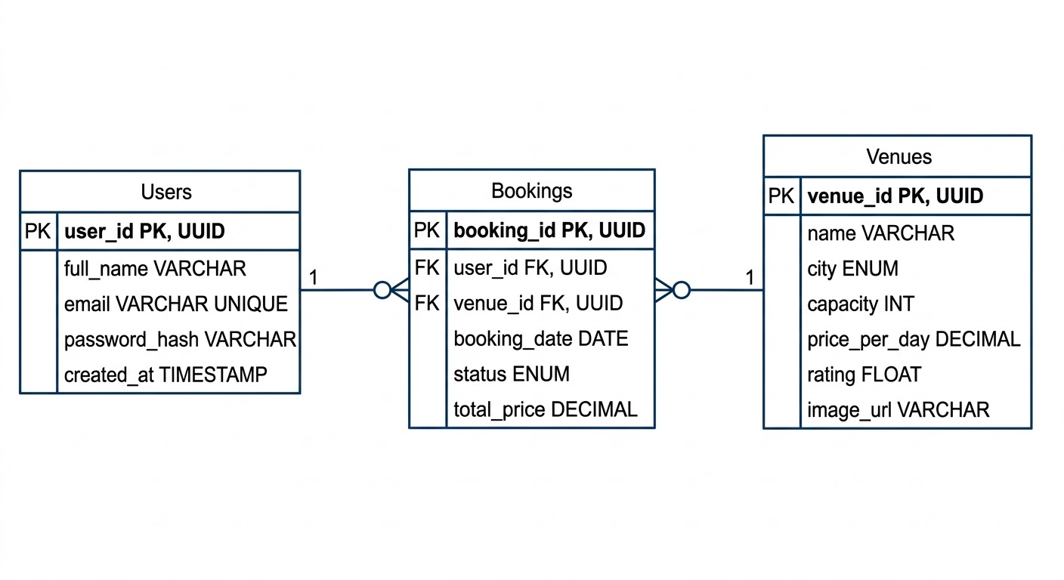

3. Functional Requirements

3.1 User Authentication
- FR-1: Users shall be able to register using an email address or via third-party OAuth (Google).
- FR-2: Registered users shall be able to login/logout securely.

3.2 Search & Discovery
- FR-3: The system shall provide a search bar to filter venues by Location, Date, and Guest Capacity.
- FR-4: The homepage shall display "Featured Venues" with key details: Title, City, Rating, Capacity, and Price.

3.3 Venue Management & Booking
- FR-5: The system shall display individual venue profiles with high-quality images.
- FR-6: Users shall be able to view the availability of a venue for a specific date.
- FR-7: The system shall calculate the total price based on the "Starting from" daily rate.

4. Non-Functional Requirements
- Usability: The UI should be clean, modern, and responsive for both desktop and mobile users.
- Performance: Search results should load within 2 seconds.
- Scalability: The system should handle multiple simultaneous booking requests without data conflicts.
- Security: All payment and user data must be encrypted using HTTPS.

5. Technical Stack
Component | Technology
Frontend | HTML5, CSS3, JavaScript (React or Vanilla)
Backend | Node.js / Express or Python (Django/Flask)
Database | MongoDB or PostgreSQL
Tools | VS Code, Git/GitHub

